

Week-1

1)Aim: To implement recursion in Python by creating a function that prints numbers in descending order from a given number.
Program:
"question 1"

def countdown(n):
if n > 0:
print(n)
countdown(n - 1)
n = int(input("Enter the countdown time:"))
countdown(n)
print("rocket launches!!")
Output:
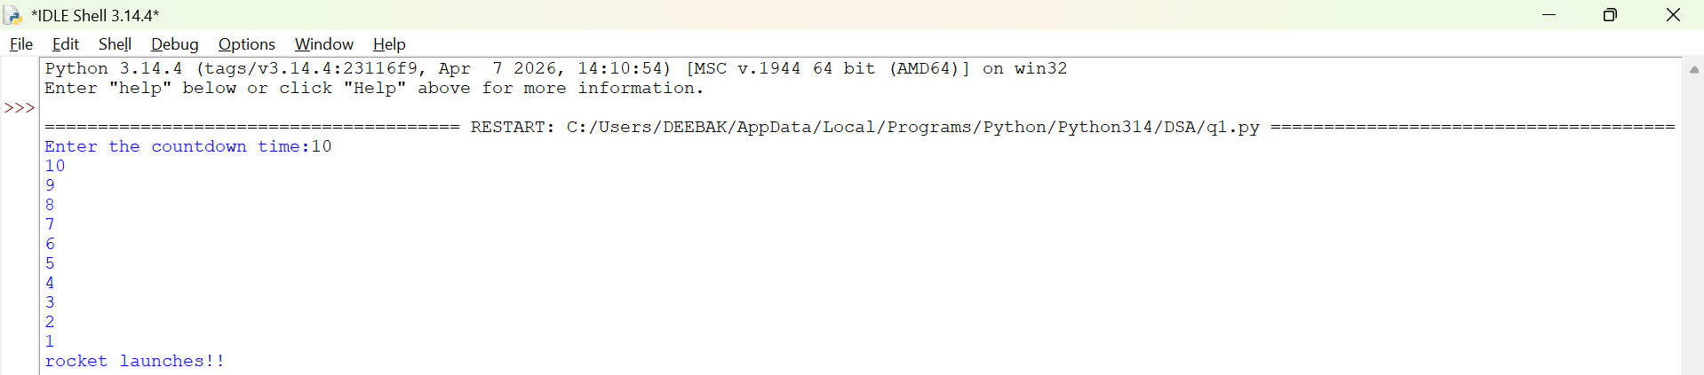
Explanation:
• The function launch(n) prints the current value of n.
• If n is greater than 0, it decreases n by 1 and calls itself recursively.
• The recursion continues until n becomes 0, which is the base case, and the function stops.

Error Table:
S.No | Error Obtained | Rectification
01. | Didn’t write the print statement after definition. | After execution I found the mistake and added it.

2)Aim: To implement a recursive binary search in Python to find the position (index) of a given element in a list. The program recursively checks each element of the list until the target element is found or the end of the list is reached.
Program:
"question 3"

def search(emp_list, key, index):
if index == len(emp_list):
return False
if emp_list[index] == key:
return True
return search(emp_list, key, index +1)
emp_list = [1000, 1001, 1002, 1003, 1004]
key = int(input("Enter employee to search"))

if search(emp_list, key, 0):
print("Employee ID found")
else:
print("Employee ID not found")

Output:
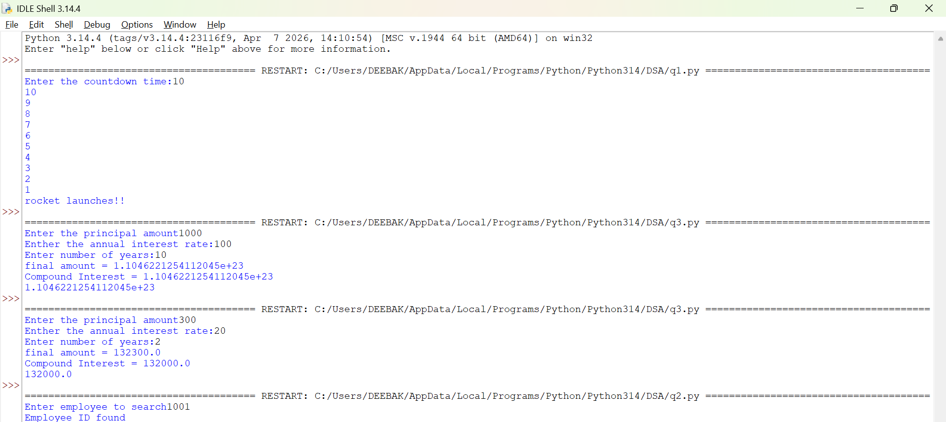

Explanation:
This program uses recursion to perform a linear search for an employee ID (or any target element) in a list.
- The function empid_Search(arr, target, n=0) is defined with three parameters:
  - arr: The list in which the search is performed.
  - target: The element to be searched.
  - n: The current index, initialized to 0.
- The statement if n == len(arr): return -1 is the base condition. It checks whether all elements in the list have been examined. If the end of the list is reached without finding the target, the function returns -1.
- The statement if arr[n] == target: return n compares the current element with the target. If they are equal, the function returns the current index where the target is found.
- If the current element does not match the target, the function calls itself recursively with the next index using return empid_Search(arr, target, n + 1).
- The list arr = [10, 20, 30, 50, 607, 809, 506] is created, and the function is called to search for the element 50.
- The returned value is stored in the variable result.
- If result is not equal to -1, the program prints the index where the element is found. Otherwise, it prints "Element not found."
Error table:
S.No | Error Obtained | Rectification
01. | Recursion Error: maximum recursion depth exceeded | Increment the index in the recursive call: return empid_Search(arr, target, n + 1).

3)Aim: This Python program uses recursion to calculate the value of pⁿ (p raised to the power n).
Program:
"question 2"

def power(base, exp):
if exp == 0:
return 1
return base * power(base, exp - 1)

P = float(input("Enter the principal amount"))
r = float(input("Enther the annual interest rate:"))
n = int(input("Enter number of years:"))
A = P * power(1 + r, n)
compound_interest = A - P
print("final amount =", round(A, 2))
print("Compound Interest =", round(compound_interest, 2))
print(compound_interest)
Output:
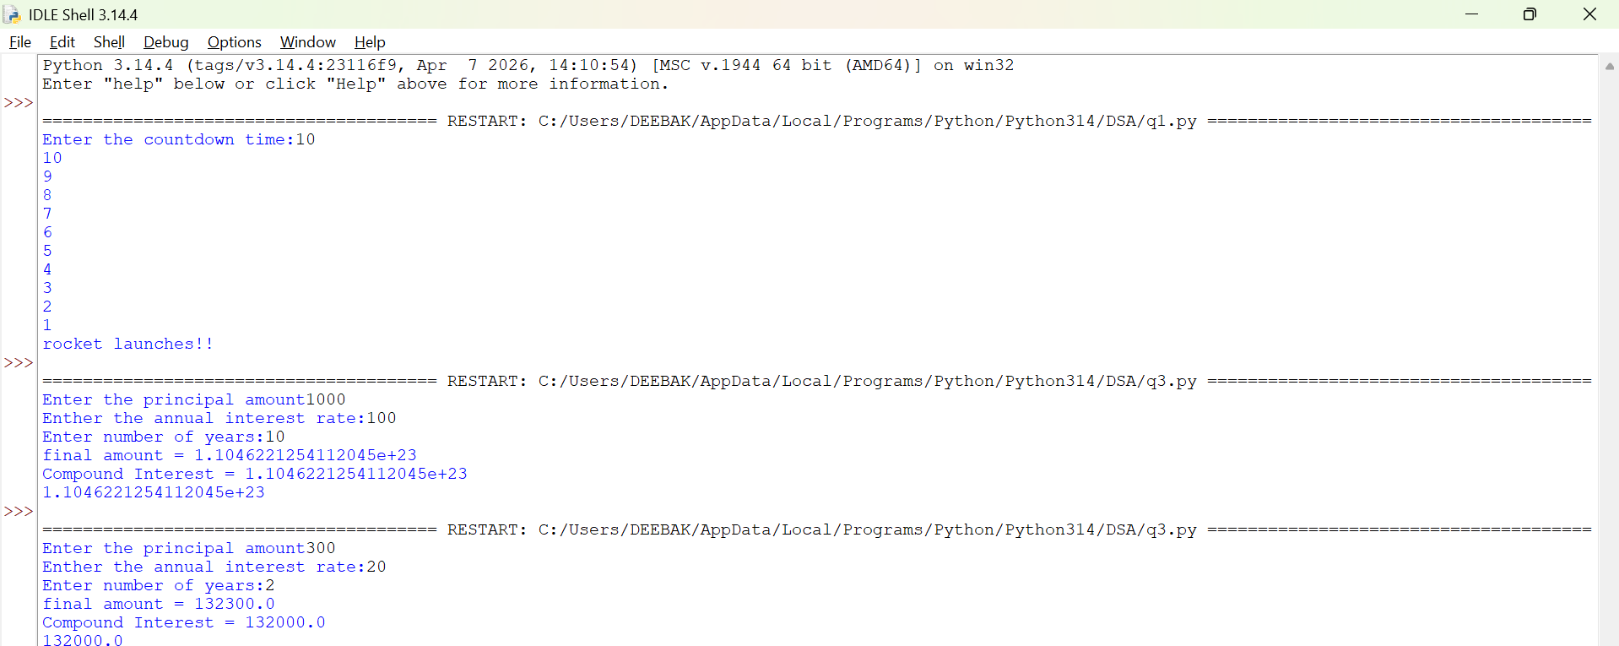
Explanation:
• The program is used to find the power of a number (pⁿ) using recursion.
• It takes two inputs from the user:
- p → Base number
- n → Exponent (power)
• The function power(p, n) is called to calculate the result.
• If the exponent n is 0, the function returns 1 because any number raised to the power 0 is
• If n is not 0, the function calls itself with n - 1 and multiplies the result by p.
• This recursive process continues until the exponent becomes 0.
• After reaching the base case, each recursive call returns its result, and the final value of pⁿ is obtained.
• The result is stored in the variable result.
• Finally, the program prints the calculated power of the given number.

Error Table:
S.No | Error Obtained | Rectification
01. | Not a int value of n we can also take float in place of int, I have taken float value to check. | By replacing int by float.

4)Aim: To write a Python program that generates and prints the Fibonacci series up to n terms using recursion.
Program:
"question 4"

def factorial(n):
if n == 0 or n == 1:
return 1
return n*factorial(n - 1)

n = int(input("Enter the number of possible ways to arrange n different parcels: "))
factorial(n)
print(factorial(n))
Output:
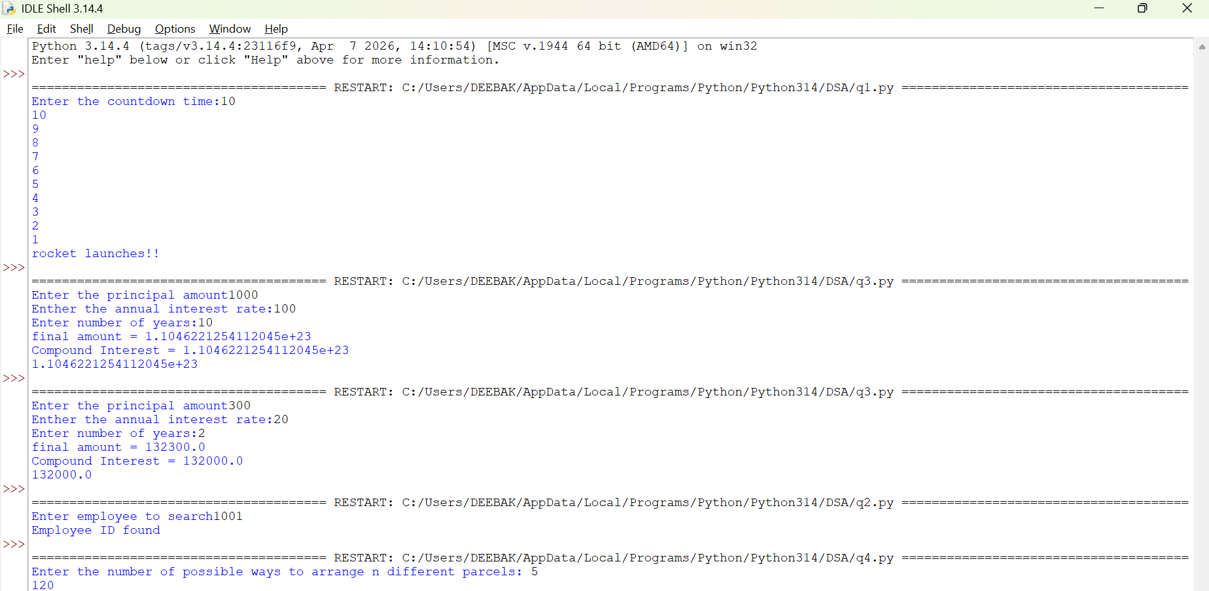

Explanation:
• The program uses a recursive function fib(n) to generate Fibonacci numbers.
• The base condition returns 0 when n = 0 and 1 when n = 1.
• For values greater than 1, the function returns the sum of the previous two Fibonacci numbers: fib(n-1) + fib(n-2).
• The user enters the number of terms (n) to be displayed.
• A for loop calls the fib() function repeatedly for each term from 0 to n-1.
• Finally, the program prints the Fibonacci series in sequence.
Error Table:
S.No | Error Obtained | Rectification
01. | No Errors obtained | -----------------------------------------

5)Aim: To write a Python program to find the factorial of a given number using recursion.
Program:
"question 5"

def fibbanocci(n):
if n == 0 or n == 1:
return 1
return fibbanocci(n - 1) + fibbanocci(n - 2)
n = int(input("Enter the number of fibbanocci terms"))
fibbanocci(n)
print(fibbanocci(n))
Output:
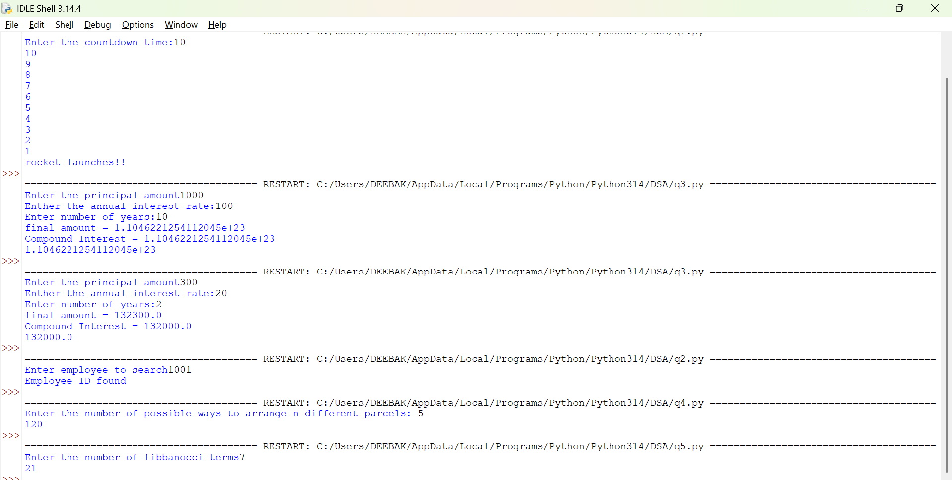

Explanation:
• The program defines a recursive function fact(n) to calculate the factorial of a number.
• The base condition checks if n <= 1. If true, it returns 1 (for factorial, 0! = 1 and 1! = 1).
• Otherwise, the function returns n * fact(n-1), multiplying the current number by the factorial of the previous number.
• The function is called with the value 6.
• Finally, the program prints the factorial of 6, which is 720.
Error Table:
S.No | Error Obtained | Rectification
01. | No Errors obatined | ---------------------------------------------------
Week-2
1)Aim:- Write a program to perform linear search on the given input.
Program:-
"""question1

write a python program to perform Linear Search on the given input"""

def linear_search(arr, key):
for i in range(len(arr)):
if arr[i] == key:
return i
return -1
n = int (input("Enter no of element : "))
arr = []
for j in range(n):
a = int(input("Enter the values of the array : "))
arr.append(a)
key = int(input("Enter the element to search : "))
result = linear_search(arr, key)
if result != -1:
print("Element found at index", result)
else:
print("Element not found")
Output:-
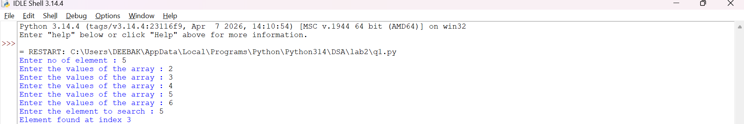
Explanation:-
This program uses a linear search technique to find a target element in a list.
- The function linear_search(arr, target) is defined with two parameters:
  - arr: The list in which the search is performed.
  - target: The element to be searched.
- A for loop is used to traverse each element of the list from index 0 to len(arr) - 1.
- The statement if arr[i] == target: compares each element of the list with the target element.
- If the element is found, the function returns "at position", i + 1, which gives the position of the element (starting from 1).
- If the loop completes without finding the element, the function returns "element not found".
- An empty list a is created, and the user is asked to input elements continuously.
- The loop continues until the user enters "stop", after which the input process ends.
- The user then enters the element to be searched, which is stored in variable b.
- The function is called using linear_search(a, b) and the result is printed.

Error Table and negatives where the code doesn’t give the effective result:-
S.No | Error Obtained | Rectification
01 | ValueError when entering non-integer input | Ensure only integer values are entered or handle using
02 | Program crashes if empty input is given before converting to int | Validate input before conversion
03 | Element not found even if list is empty | Check if list is empty before searching
04 | If duplicate elements exist, only first occurrence is returned | Modify logic if all occurrences are needed
05 | Program does not handle very large lists efficiently | Use better algorithms like binary search (for sorted lists)
2)Aim:-Write a python program to perform binary search on the given input verify by taking sorted array and unsorted array as a input:-
Program:-
(a)Sorted Array:
""" question 2
Write a python program to perform Binary Search on the given input.
Verify by taking Sorted array and unsorted array as a input"""

""" question 2(sorted array)"""

def binary_search(arr, key):
low = 0
high = len(arr) - 1
while low <= high :
mid = (low + high ) // 2
if arr[mid] == key:
return mid
elif arr[mid] < key:
low = mid + 1
else:
high = mid - 1
return -1
n = int(input("Enter no of elements : "))
arr = []
for i in range(n):
a = int(input("Enter the elements of the array : "))
arr.append(a)
key = int(input("Enter the elements to search : "))
result = binary_search(arr, key)
if result != -1:
print("Element found at the index : ",result)
else:
print("Element is not found")

(b) Unsorted Array:
"""question 2(array is not sorted)"""

def binary_search(arr, key):
low = 0
high = len(arr) - 1
while low <= high:
mid = (low + high)// 2
if arr[mid] == key:
return mid
elif arr[mid] < key:
low = mid +1
else:
high = mid - 1
return -1
n = int(input("Enter the no of elements of the array : "))
arr = []
for i in range(n):
a = int(input("Enter the elements of the array : "))
arr.append(a)
key = int(input("Enter the element to search : "))
if arr == sorted(arr):
print("The input list is already sorted")
else:
print("The input list is not sorted")
print("Sorting the element")
arr.sort()
print("Sorted List : ", arr)
result = binary_search(arr, key)
if result != -1:
print("Element found at the index : ",result)
else:
print("Element not found")

Output:-
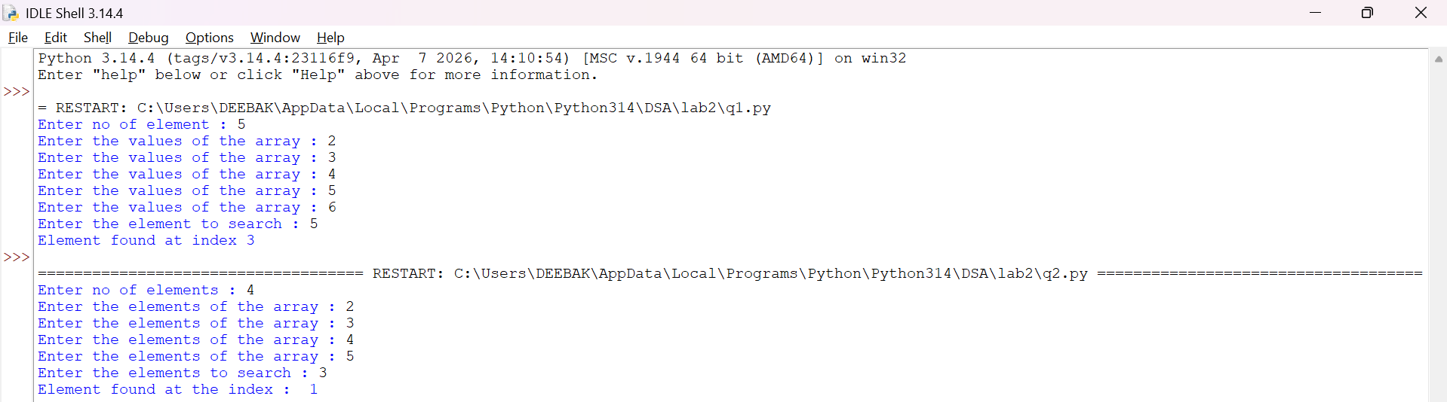
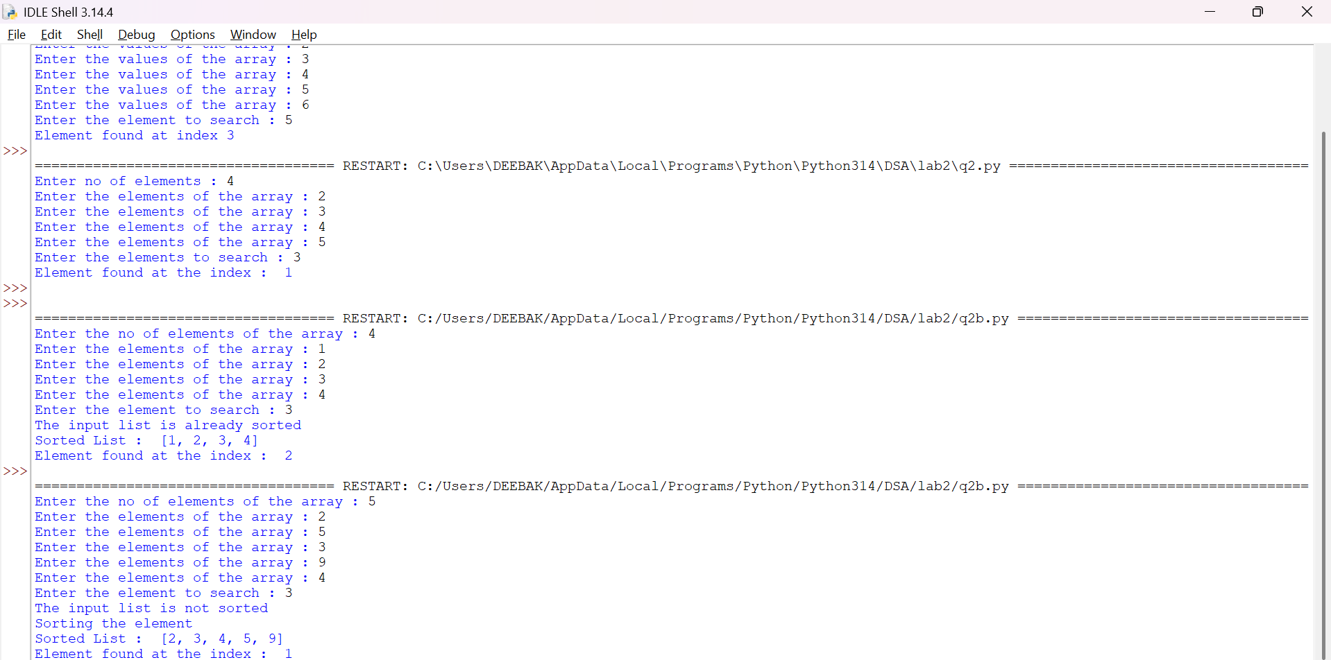
Explanation:-
This program uses the binary search technique to find a target element in a list.
- The function binary_search(arr, target) is defined to perform the search operation.
- Two variables are initialized:
  - low = 0: Represents the starting index of the list.
  - high = len(arr) - 1: Represents the last index of the list.
- A while loop runs as long as low <= high, ensuring the search space is valid.
- The middle index is calculated using mid = (low + high) // 2.
- The statement if arr[mid] == target: checks whether the middle element is equal to the target.
  - If true, the function returns "at position", mid.
- If the target is greater than the middle element (target > arr[mid]), the search continues in the right half by updating low = mid + 1.
- Otherwise, the search continues in the left half by updating high = mid - 1.
- The user inputs elements into the list a until "stop" is entered.
- The list is sorted using a.sort().
  - This ensures that even if the user enters an unsorted array, the binary search will still work correctly.
- The user enters the element to be searched, stored in variable b.
- The function is called using binary_search(a, b) and the result is printed.
Error Table and negatives where the code doesn’t give the effective result:-
Sno | Error Obtained | Rectification
01 | ValueError when non-integer input is entered | Ensure inputs are integers or use
02 | Incorrect position (0-based index returned) | Use mid + 1 if position should start from 1
03 | Program fails if list is empty | Check if list is empty before searching
04 | Binary search requires sorted array | Sorting is already handled using
05 | Element not found but no explicit message returned | Add return "element not found" after loop
06 | Output format shows tuple like ('at position', 2) | Use formatted print statement for better output
07 | Duplicate elements return only one occurrence | Modify logic if all positions are needed
08 | Sorting changes original order of elements | Inform user that positions are based on sorted list

WEEK-3
3a)Aim:- Write a Python program to perform Bubble Sort on a given list of elements.
Program:-
def bubble_sort(arr):
n = len(arr)
for i in range(n):
swapped = False
for j in range(0, n - i - 1):
if arr[j] > arr[j + 1]:
arr[j], arr[j + 1] = arr[j + 1], arr[j]
swapped = True
if not swapped:
break
return arr

a = []
while True:
elem = input("Enter an element (or enter stop to finish):- ")
if elem.lower() == "stop":
break
a.append(int(elem))

print("Original List:", a)
sorted_list = bubble_sort(a)
print("Sorted List: ", sorted_list)
OUTPUT:-
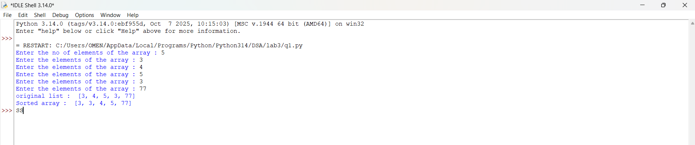
Explanation:
This program uses the Bubble Sort technique to sort elements in a list.
- The function bubble_sort(arr) is defined to sort the given list arr.
- The variable n = len(arr) stores the number of elements in the list.
- A loop runs from i = 0 to n-1, representing each pass of the sorting process.
- A variable swapped is initialized as False at the beginning of each pass.
  - It is used to check whether any swapping occurred during the pass.
- Another loop runs from j = 0 to n-i-2, comparing adjacent elements.
- The condition if arr[j] > arr[j + 1]: checks if the current element is greater than the next element.
  - If true, the elements are swapped using arr[j], arr[j + 1] = arr[j + 1], arr[j].
  - The variable swapped is set to True.
- After each pass, if no swapping occurs (swapped == False), the loop breaks early.
  - This indicates that the list is already sorted.
- The function returns the sorted list.
- The user inputs elements into the list a until "stop" is entered.
- The original list is printed, followed by the sorted list after calling bubble_sort(a).

Error Table:
S.No | Error Obtained | Rectification
01. | ValueError when non-integer input is entered | Ensure input is integer or handle using try-except
02. | Program fails for empty list (no elements entered) | Check if list is empty before sorting
03. | Sorting modifies original list | Use a copy of list if original order must be preserved
04. | Inefficient for large inputs (high time complexity) | Use faster algorithms like merge sort or quick sort
3b)
Aim:-
Write a Python program to perform Insertion Sort on a given list of elements.
Program:-
def insertion_sort(arr):
for i in range(1, len(arr)):
key = arr[i]
j = i - 1
while j >= 0 and key < arr[j]:
arr[j + 1] = arr[j]
j -= 1
arr[j + 1] = key
return arr

a = []
while True:
elem = input("Enter an element (or enter stop to finish):- ")
if elem.lower() == "stop":
break
a.append(int(elem))

print("Original List:", a)
sorted_list = insertion_sort(a)
print("Sorted List: ", sorted_list)
Output:-
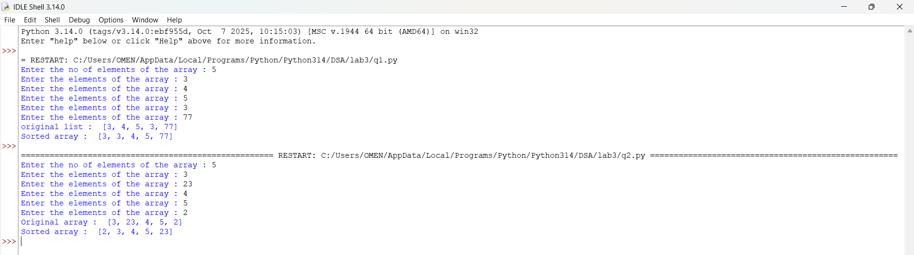
Explanation:
This program uses the Insertion Sort technique to sort elements in a list.
- The function insertion_sort(arr) is defined to sort the given list arr.
- A loop runs from i = 1 to len(arr) - 1, considering one element at a time as the key element.
- The variable key = arr[i] stores the current element to be inserted into the sorted portion of the list.
- The variable j = i - 1 points to the last element of the already sorted portion.
- A while loop runs as long as j >= 0 and key < arr[j].
  - This shifts elements one position ahead using arr[j + 1] = arr[j].
  - The value of j is decreased by 1 after each shift.
- After shifting all larger elements, the key is placed at the correct position using arr[j + 1] = key.
- This process continues until the entire list is sorted.
- The function returns the sorted list.
- The user inputs elements into the list a until "stop" is entered.
- The original list is printed, followed by the sorted list after calling insertion_sort(a).

Error Table:
S.No | Error Obtained | Rectification
01. | ValueError when non-integer input is entered | Ensure input is integer or handle using try-except
02. | Program fails for empty list | Check if list is empty before sorting
03. | Sorting modifies original list | Use a copy of list if original order must be preserved
04. | Incorrect output if comparison condition is wrong (key > arr[j]) | Ensure correct condition key < arr[j] is used
3c)
Aim:-
Write a Python program to perform Selection Sort on a given list of elements.
Program:-
def selection_sort(arr):
n = len(arr)
for i in range(n):
min_idx = i
for j in range(i + 1, n):
if arr[j] < arr[min_idx]:
min_idx = j
arr[i], arr[min_idx] = arr[min_idx], arr[i]
return arr

a = []
while True:
elem = input("Enter an element (or enter stop to finish):- ")
if elem.lower() == "stop":
break
a.append(int(elem))

print("Original List:", a)
sorted_list = selection_sort(a)
print("Sorted List: ", sorted_list)
Output:-
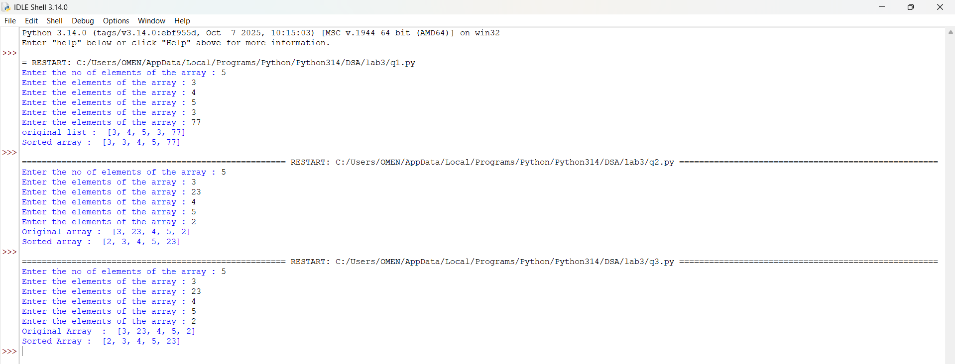
Explanation:
This program uses the Selection Sort technique to sort elements in a list.
- The function selection_sort(arr) is defined to sort the given list arr.
- The variable n = len(arr) stores the number of elements in the list.
- A loop runs from i = 0 to n-1, representing the position where the smallest element should be placed.
- The variable min_idx = i is initialized to store the index of the minimum element in the unsorted portion.
- Another loop runs from j = i + 1 to n-1, comparing elements in the unsorted part of the list.
- The condition if arr[j] < arr[min_idx]: checks if a smaller element is found.
  - If true, min_idx is updated with the index of that smaller element.
- After finding the smallest element, it is swapped with the element at position i using
arr[i], arr[min_idx] = arr[min_idx], arr[i].
- This process continues until the entire list is sorted.
- The function returns the sorted list.
- The user inputs elements into the list a until "stop" is entered.
- The original list is printed, followed by the sorted list after calling selection_sort(a).

Error Table:
S.No | Error Obtained | Rectification
01. | ValueError when non-integer input is entered | Ensure input is integer or handle using try-except
02. | Program fails for empty list | Check if list is empty before sorting
03. | Sorting modifies original list | Use a copy of list if original order must be preserved
04. | Incorrect sorting if comparison condition is wrong (arr[j] > arr[min_idx]) | Ensure correct condition arr[j] < arr[min_idx] is used

3d)
Aim:-
Write a Python program to perform Merge Sort on a given list of elements.
Program:-
def merge_sort(arr):
if len(arr) > 1:
mid = len(arr) // 2
L = arr[:mid]
R = arr[mid:]

merge_sort(L)
merge_sort(R)

i = j = k = 0

while i < len(L) and j < len(R):
if L[i] <= R[j]:
arr[k] = L[i]
i += 1
else:
arr[k] = R[j]
j += 1
k += 1

while i < len(L):
arr[k] = L[i]
i += 1
k += 1

while j < len(R):
arr[k] = R[j]
j += 1
k += 1
return arr

a = []
while True:
elem = input("Enter an element (or enter stop to finish):- ")
if elem.lower() == "stop":
break
a.append(int(elem))

print("Original List:", a)
sorted_list = merge_sort(a)
print("Sorted List: ", sorted_list)
Output:-
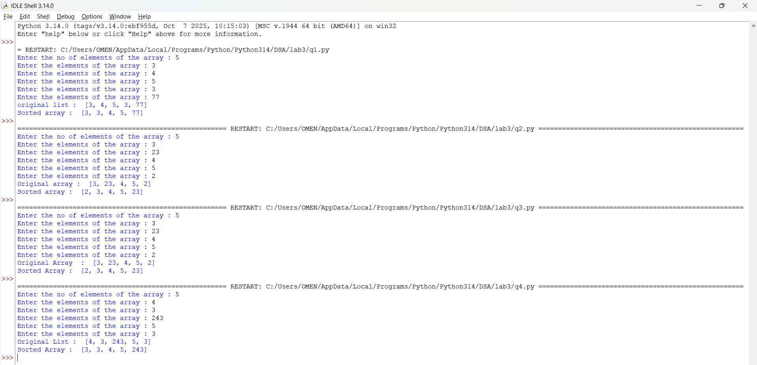
Explanation:
This program uses the Merge Sort technique to sort elements in a list using recursion.
- The function merge_sort(arr) is defined to sort the given list arr.
- The condition if len(arr) > 1: checks whether the list has more than one element.
  - If not, the list is already sorted (base case).
- The list is divided into two halves:
  - mid = len(arr) // 2 finds the middle index.
  - L = arr[:mid] stores the left half.
  - R = arr[mid:] stores the right half.
- The function recursively calls itself on both halves using merge_sort(L) and merge_sort(R).
- Three variables i, j, and k are initialized to 0:
  - i → index for left sublist
  - j → index for right sublist
  - k → index for merged list
- A while loop compares elements of L and R:
  - The smaller element is placed into arr[k].
  - Corresponding indices are incremented.
- After one sublist is exhausted, remaining elements of the other sublist are copied using two separate while loops.
- The sorted elements are merged back into the original list arr.
- The function returns the sorted list.
- The user inputs elements into the list a until "stop" is entered.
- The original list is printed, followed by the sorted list after calling merge_sort(a).

Error Table:
S.No | Error Obtained | Rectification
01. | ValueError when non-integer input is entered | Ensure input is integer or handle using try-except
02. | Program fails for empty list | Check if list is empty before sorting
03. | Incorrect merging if indices (i, j, k) are not updated properly | Ensure all indices are incremented correctly
04. | High memory usage due to creating sublists (L and R) | Use optimized in-place merge sort if required
3e)
Aim:- Write a Python program to perform Quick Sort on a given list of elements.
Program:-
def quick_sort(arr, low=0, high=None):
if high is None:
high = len(arr) - 1

if low < high:
pivot = arr[high]
i = low - 1

for j in range(low, high):
if arr[j] <= pivot:
i += 1
arr[i], arr[j] = arr[j], arr[i]
arr[i + 1], arr[high] = arr[high], arr[i + 1]
pi = i + 1
quick_sort(arr, low, pi - 1)
quick_sort(arr, pi + 1, high)

return arr

a = []
while True:
elem = input("Enter an element (or enter stop to finish):- ")
if elem.lower() == "stop":
break
a.append(int(elem))

print("Original List:", a)
sorted_list = quick_sort(a)
print("Sorted List: ", sorted_list)
Output:-
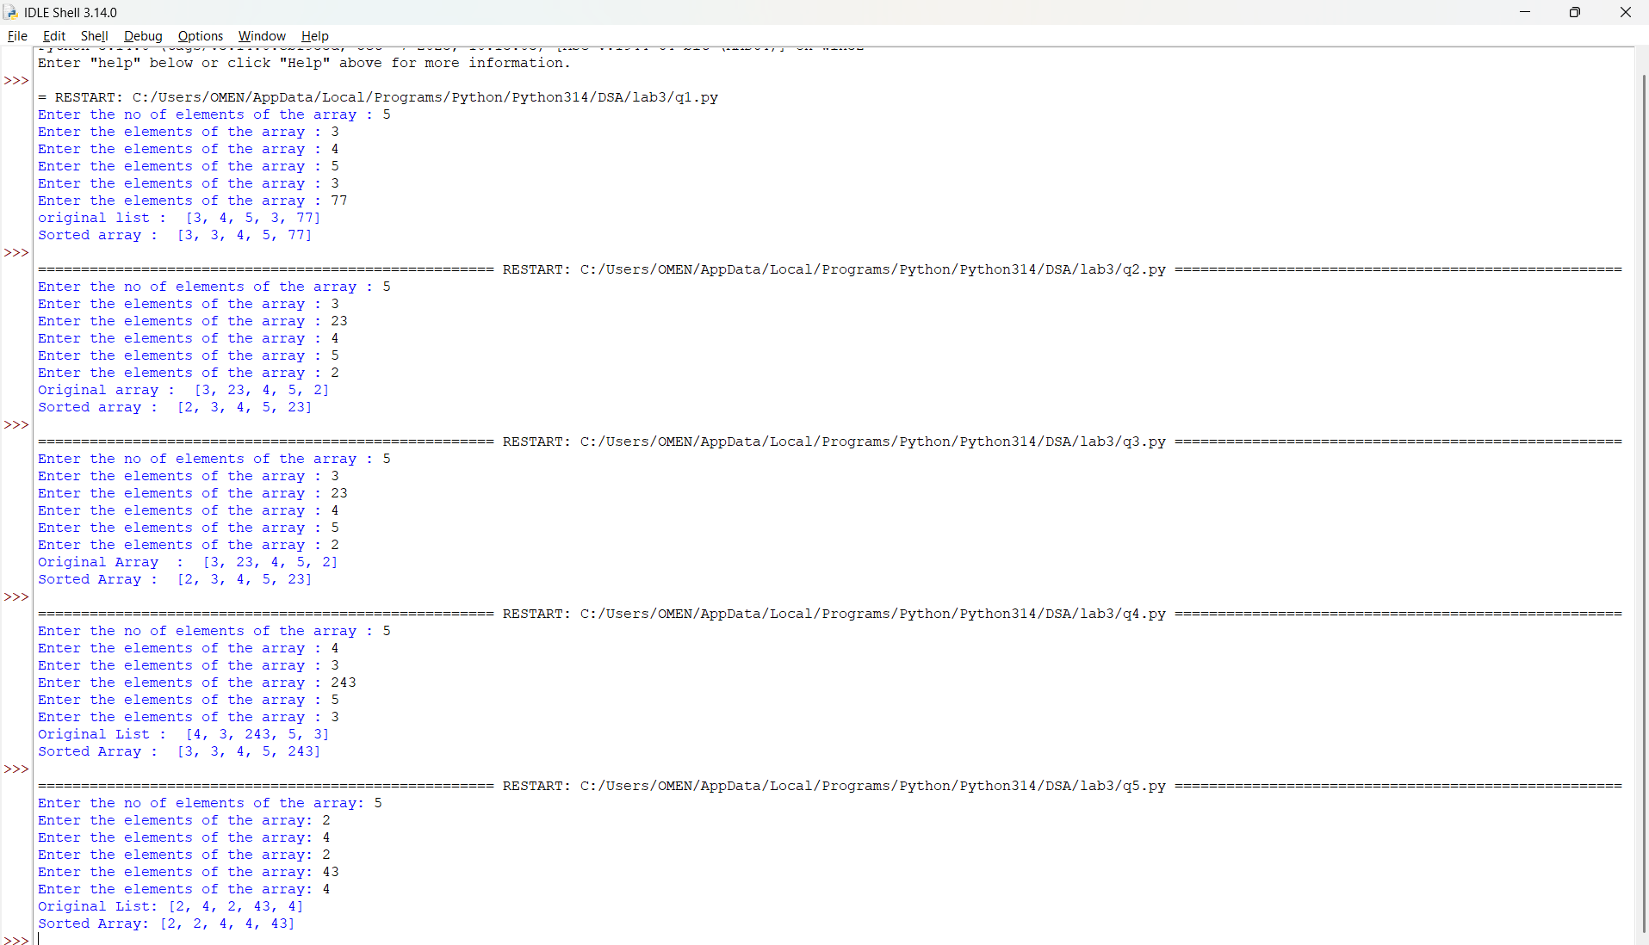

Explanation:
This program uses the Quick Sort technique to sort elements in a list using recursion.
- The function quick_sort(arr, low=0, high=None) is defined with parameters:
  - arr: The list to be sorted
  - low: Starting index (default 0)
  - high: Ending index (default last index of list)
- If high is None, it is initialized as len(arr) - 1.
- The condition if low < high: ensures that sorting is performed only when there are at least two elements.
- The last element arr[high] is chosen as the pivot.
- The variable i = low - 1 is used to track the position of smaller elements.
- A loop runs from j = low to high - 1:
  - If arr[j] <= pivot, i is incremented and elements are swapped using
arr[i], arr[j] = arr[j], arr[i].
- After the loop, the pivot is placed at its correct position using
arr[i + 1], arr[high] = arr[high], arr[i + 1].
- The pivot index pi = i + 1 divides the array into two parts.
- The function recursively sorts:
  - Left subarray → quick_sort(arr, low, pi - 1)
  - Right subarray → quick_sort(arr, pi + 1, high)
- The function returns the sorted list.
- The user inputs elements into list a until "stop" is entered.
- The original list and sorted list are printed.

Error Table:
S.No | Error Obtained | Rectification
01. | ValueError when non-integer input is entered | Ensure input is integer or handle using try-except
02. | Program fails for empty list | Check if list is empty before sorting
03. | Worst-case performance (O(n²)) for already sorted list | Use better pivot selection (e.g., middle or random pivot)
04. | Recursion depth error for very large lists | Increase recursion limit or use iterative approach

WEEK-4

4(a)Aim:-
Write a Python program to implement a Singly Linked List with the following operations:
- Create a singly linked list with n nodes.
- Insert a node at the beginning of the linked list.
- Insert a node at the end of the linked list.
- Insert a node at a specific position.
- Delete a node by its value.
- Delete the first node.
- Delete the last node.
- Count the number of nodes in the linked list.
- Display/Traverse the linked list.
- Exit the program.
Implement the above operations using a menu-driven program and a Node class.
PROGRAM:-
class Node: def init(self, data): self.data = data self.next = None
class SinglyLinkedList:
def __init__(self):
self.head = None
def create(self):
n = int(input("Enter number of nodes: "))
if n <= 0:
print("Number of nodes must be greater than 0.")
return
for i in range(n):
data = int(input(f"Enter data for node {i + 1}: "))
new_node = Node(data)
if self.head is None:
self.head = new_node
else:
temp = self.head
while temp.next is not None:
temp = temp.next
temp.next = new_node
print("Linked List created successfully.")
def insert_beginning(self, data):
new_node = Node(data)
new_node.next = self.head
self.head = new_node
print("Node inserted successfully.")
def insert_end(self, data):
new_node = Node(data)
if self.head is None:
self.head = new_node
print("Node inserted successfully.")
return
temp = self.head
while temp.next is not None:
temp = temp.next
temp.next = new_node
print("Node inserted successfully.")
def insert_at_position(self, data, position):
if position < 1:
print("Invalid position.")
return
new_node = Node(data)
if position == 1:
new_node.next = self.head
self.head = new_node
print("Node inserted successfully.")
return
temp = self.head
for i in range(position - 2):
if temp is None:
print("Invalid position.")
return
temp = temp.next
if temp is None:
print("Invalid position.")
return
new_node.next = temp.next
temp.next = new_node
print("Node inserted successfully.")
def delete_by_value(self, value):
if self.head is None:
print("Linked List is empty.")
return
if self.head.data == value:
self.head = self.head.next
print("Node deleted successfully.")
return
temp = self.head
while temp.next is not None:
if temp.next.data == value:
temp.next = temp.next.next
print("Node deleted successfully.")
return
temp = temp.next
print("Value not found.")
def delete_first(self):
if self.head is None:
print("Linked List is empty.")
return
deleted_value = self.head.data
self.head = self.head.next
print("First node deleted:", deleted_value)
def delete_last(self):
if self.head is None:
print("Linked List is empty.")
return
if self.head.next is None:
deleted_value = self.head.data
self.head = None
print("Last node deleted:", deleted_value)
return
temp = self.head
while temp.next.next is not None:
temp = temp.next
deleted_value = temp.next.data
temp.next = None
print("Last node deleted:", deleted_value)
def count_nodes(self):
count = 0
temp = self.head
while temp is not None:
count += 1
temp = temp.next
print("Number of nodes:", count)
def display(self):
if self.head is None:
print("Linked List is empty.")
return
temp = self.head
print("Linked List:")
while temp is not None:
print(temp.data, end=" -> ")
temp = temp.next
print("None")
sll = SinglyLinkedList()
while True:
print("\n======================================")
print(" SINGLY LINKED LIST")
print("======================================")
print("1. Create Linked List")
print("2. Insert at beginning")
print("3. Insert at end")
print("4. Insert at specific position")
print("5. Delete by value")
print("6. Delete First Node")
print("7. Delete Last Node")
print("8. Count no of nodes")
print("9. Display / Traverse")
print("10. Exit")
print("======================================")
ch = int(input("Enter your choice: "))
if ch == 1:
sll.create()
elif ch == 2:
data = int(input("Enter data: "))
sll.insert_beginning(data)
elif ch == 3:
data = int(input("Enter data: "))
sll.insert_end(data)
elif ch == 4:
data = int(input("Enter data: "))
position = int(input("Enter position (starting from 1): "))
sll.insert_at_position(data, position)
elif ch == 5:
value = int(input("Enter value to delete: "))
sll.delete_by_value(value)
elif ch == 6:
sll.delete_first()
elif ch == 7:
sll.delete_last()
elif ch == 8:
sll.count_nodes()
elif ch == 9:
sll.display()
elif ch == 10:
print("Exiting program...")
break
else:
print("Invalid choice. Please enter a number between 1 and 10.")
OUTPUT:
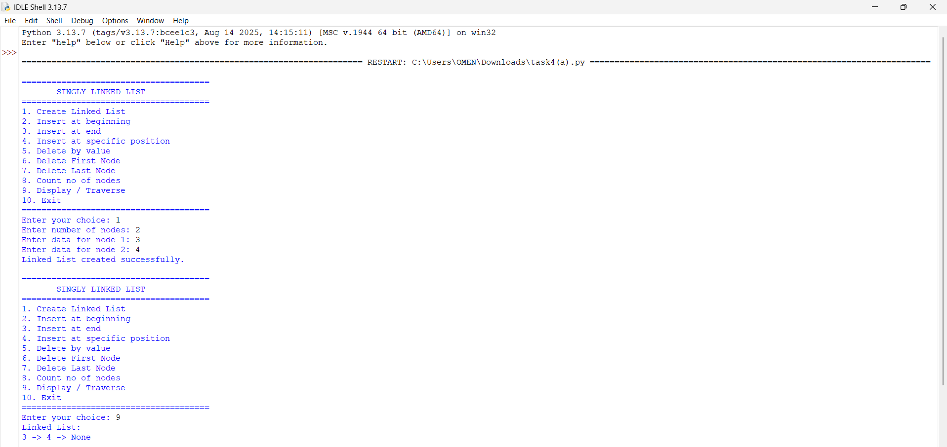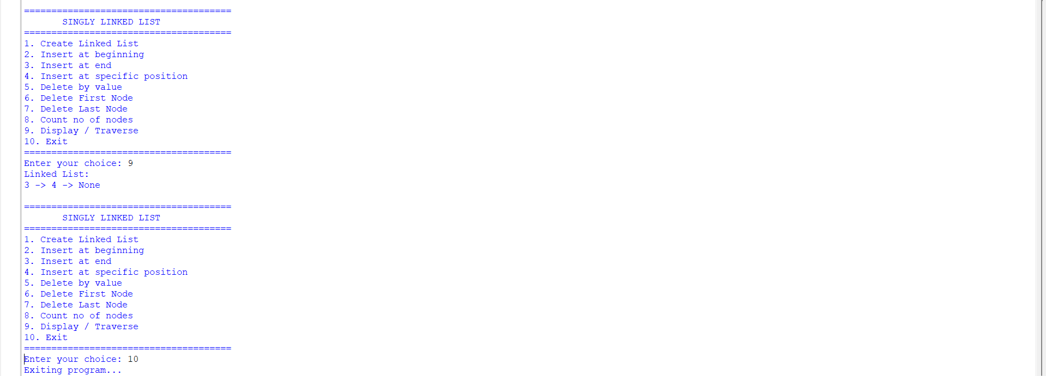

Explanation:
- The program implements a Singly Linked List using Node and SinglyLinkedList classes.
- Each node contains data and a next pointer that stores the reference to the next node.
- The head points to the first node of the linked list.
- The program supports insertion at the beginning, end, and a specific position.
- It supports deletion by value, from the beginning, and from the end.
- The count_nodes() function counts the total number of nodes.
- The display() function traverses and prints all nodes in the list.
- A menu-driven program is used to allow the user to select different operations.

4(b)aim:-
To write a Python program to implement a Doubly Linked List and perform insertion, deletion, counting, and traversal operations in both forward and backward directions.

Program:-
class Node: def init(self, data): self.data = data self.prev = None self.next = None
class DoublyLinkedList: def init(self): self.head = None
def create(self):
n = int(input("Enter number of nodes: "))
if n <= 0:
print("Number of nodes must be greater than 0.")
return
for i in range(n):
data = int(input(f"Enter data for node {i + 1}: "))
new_node = Node(data)
if self.head is None:
self.head = new_node
else:
temp = self.head
while temp.next is not None:
temp = temp.next
temp.next = new_node
new_node.prev = temp
print("Linked List created successfully.")
def insert_beginning(self):
data = int(input("Enter data: "))
new_node = Node(data)
if self.head is None:
self.head = new_node
else:
new_node.next = self.head
self.head.prev = new_node
self.head = new_node
print("Node inserted at beginning.")
def insert_end(self):
data = int(input("Enter data: "))
new_node = Node(data)
if self.head is None:
self.head = new_node
else:
temp = self.head
while temp.next is not None:
temp = temp.next
temp.next = new_node
new_node.prev = temp
print("Node inserted at end.")
def insert_position(self):
position = int(input("Enter position: "))
data = int(input("Enter data: "))
if position <= 0:
print("Invalid position.")
return
new_node = Node(data)
if position == 1:
if self.head is not None:
new_node.next = self.head
self.head.prev = new_node
self.head = new_node
print("Node inserted.")
return
temp = self.head
for i in range(position - 2):
if temp is None:
print("Position does not exist.")
return
temp = temp.next
if temp is None:
print("Position does not exist.")
return
new_node.next = temp.next
new_node.prev = temp
if temp.next is not None:
temp.next.prev = new_node
temp.next = new_node
print("Node inserted.")
def delete_by_value(self):
value = int(input("Enter value to delete: "))
temp = self.head
while temp is not None:
if temp.data == value:
if temp.prev is None:
self.head = temp.next
if self.head is not None:
self.head.prev = None
else:
temp.prev.next = temp.next
if temp.next is not None:
temp.next.prev = temp.prev
print("Node deleted.")
return
temp = temp.next
print("Value not found.")
def delete_first(self):
if self.head is None:
print("Linked List is empty.")
return
self.head = self.head.next
if self.head is not None:
self.head.prev = None
print("First node deleted.")
def delete_last(self):
if self.head is None:
print("Linked List is empty.")
return
temp = self.head
while temp.next is not None:
temp = temp.next
if temp.prev is None:
self.head = None
else:
temp.prev.next = None
print("Last node deleted.")
def count(self):
count = 0
temp = self.head
while temp is not None:
count += 1
temp = temp.next
print("Number of nodes:", count)
def display_forward(self):
if self.head is None:
print("Linked List is empty.")
return
temp = self.head
print("Forward:", end=" ")
while temp is not None:
print(temp.data, end=" <-> ")
temp = temp.next
print("None")
def display_backward(self):
if self.head is None:
print("Linked List is empty.")
return
temp = self.head
while temp.next is not None:
temp = temp.next
print("Backward:", end=" ")
while temp is not None:
print(temp.data, end=" <-> ")
temp = temp.prev
print("None")
dll = DoublyLinkedList()
while True:
print("\n======================================")
print(" DOUBLY LINKED LIST")
print("======================================")
print("1. Create Linked List")
print("2. Insert at beginning")
print("3. Insert at end")
print("4. Insert at specific position")
print("5. Delete by value")
print("6. Delete First Node")
print("7. Delete Last Node")
print("8. Count no of nodes")
print("9. Display Forward")
print("10. Display Backward")
print("11. Exit")
choice = int(input("Enter your choice: "))
if choice == 1:
dll.create()
elif choice == 2:
dll.insert_beginning()
elif choice == 3:
dll.insert_end()
elif choice == 4:
dll.insert_position()
elif choice == 5:
dll.delete_by_value()
elif choice == 6:
dll.delete_first()
elif choice == 7:
dll.delete_last()
elif choice == 8:
dll.count()
elif choice == 9:
dll.display_forward()
elif choice == 10:
dll.display_backward()
elif choice == 11:
print("Program ended.")
break
else:
print("Invalid choice.")
Output:-
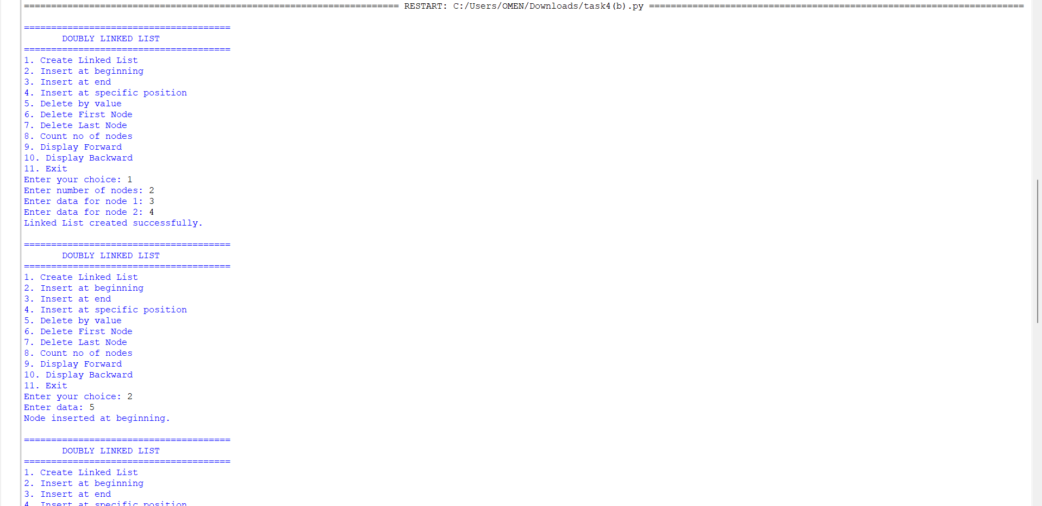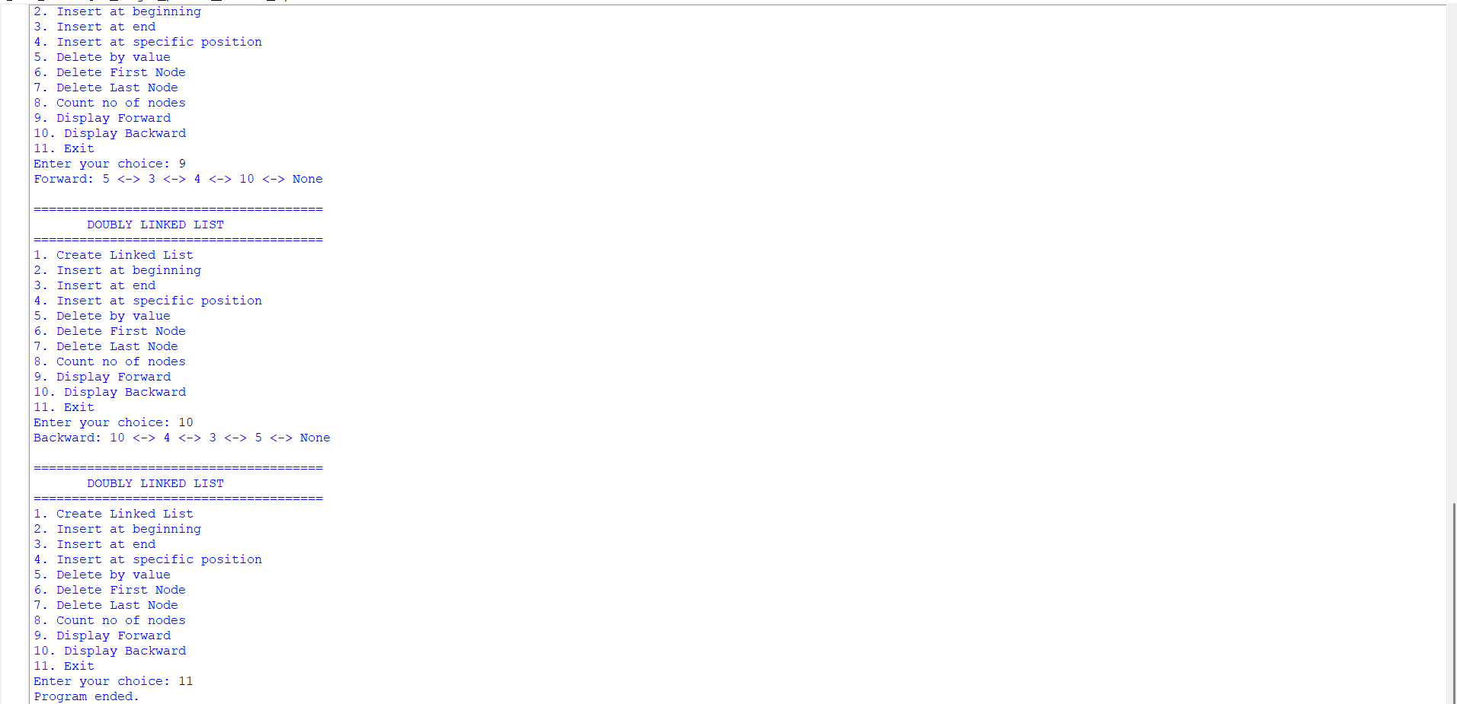

Explanation
- The program implements a Doubly Linked List using a Node class.
- Each node contains data, prev, and next references.
- The head points to the first node of the list.
- Nodes can be inserted at the beginning, end, or a specific position.
- Nodes can be deleted by value, from the beginning, or from the end.
- The program counts the nodes and displays the list in forward and backward directions.

4(c)aim:-
To write a Python program to implement a Circular Linked List and perform insertion, deletion, counting, and traversal operations.

Program:-
class Node: def init(self, data): self.data = data self.next = None
class CircularLinkedList: def init(self): self.head = None
def create(self):
n = int(input("Enter number of nodes: "))
if n <= 0:
print("Number of nodes must be greater than 0.")
return
for i in range(n):
data = int(input(f"Enter data for node {i + 1}: "))
new_node = Node(data)
if self.head is None:
self.head = new_node
new_node.next = self.head
else:
temp = self.head
while temp.next != self.head:
temp = temp.next
temp.next = new_node
new_node.next = self.head
print("Circular Linked List created successfully.")
def insert_beginning(self):
data = int(input("Enter data: "))
new_node = Node(data)
if self.head is None:
self.head = new_node
new_node.next = self.head
else:
temp = self.head
while temp.next != self.head:
temp = temp.next
new_node.next = self.head
temp.next = new_node
self.head = new_node
print("Node inserted at beginning.")
def insert_end(self):
data = int(input("Enter data: "))
new_node = Node(data)
if self.head is None:
self.head = new_node
new_node.next = self.head
else:
temp = self.head
while temp.next != self.head:
temp = temp.next
temp.next = new_node
new_node.next = self.head
print("Node inserted at end.")
def insert_position(self):
position = int(input("Enter position: "))
data = int(input("Enter data: "))
if position <= 0:
print("Invalid position.")
return
new_node = Node(data)
if position == 1:
if self.head is None:
self.head = new_node
new_node.next = self.head
else:
temp = self.head
while temp.next != self.head:
temp = temp.next
new_node.next = self.head
temp.next = new_node
self.head = new_node
print("Node inserted.")
return
if self.head is None:
print("Position does not exist.")
return
temp = self.head
for i in range(position - 2):
temp = temp.next
if temp == self.head:
print("Position does not exist.")
return
new_node.next = temp.next
temp.next = new_node
print("Node inserted.")
def delete_by_value(self):
if self.head is None:
print("Circular Linked List is empty.")
return
value = int(input("Enter value to delete: "))
current = self.head
previous = None
while True:
if current.data == value:
if current == self.head and current.next == self.head:
self.head = None
elif current == self.head:
temp = self.head
while temp.next != self.head:
temp = temp.next
self.head = self.head.next
temp.next = self.head
else:
previous.next = current.next
print("Node deleted.")
return
previous = current
current = current.next
if current == self.head:
break
print("Value not found.")
def delete_first(self):
if self.head is None:
print("Circular Linked List is empty.")
return
if self.head.next == self.head:
self.head = None
else:
temp = self.head
while temp.next != self.head:
temp = temp.next
self.head = self.head.next
temp.next = self.head
print("First node deleted.")
def delete_last(self):
if self.head is None:
print("Circular Linked List is empty.")
return
if self.head.next == self.head:
self.head = None
print("Last node deleted.")
return
temp = self.head
while temp.next.next != self.head:
temp = temp.next
temp.next = self.head
print("Last node deleted.")
def count(self):
if self.head is None:
print("Number of nodes: 0")
return
count = 0
temp = self.head
while True:
count += 1
temp = temp.next
if temp == self.head:
break
print("Number of nodes:", count)
def display(self):
if self.head is None:
print("Circular Linked List is empty.")
return
temp = self.head
print("Head to Tail:", end=" ")
while True:
print(temp.data, end=" -> ")
temp = temp.next
if temp == self.head:
break
print("(back to head)")
def display_tail_to_head(self):
if self.head is None:
print("Circular Linked List is empty.")
return
tail = self.head
while tail.next != self.head:
tail = tail.next
print("Tail to Head:", end=" ")
current = tail
while True:
print(current.data, end="")
if current == self.head:
break
print(" <- ", end="")
temp = self.head
while temp.next != current:
temp = temp.next
current = temp
print(" (reached head)")
def exit_program(self):
print("Program ended.")
cll = CircularLinkedList()
while True:
print("\n======================================")
print(" CIRCULAR LINKED LIST")
print("======================================")
print("1. Create Linked List")
print("2. Insert at beginning")
print("3. Insert at end")
print("4. Insert at specific position")
print("5. Delete by value")
print("6. Delete First Node")
print("7. Delete Last Node")
print("8. Count no of nodes")
print("9. Display Head to Tail")
print("10. Display Tail to Head")
print("11. Exit")
choice = int(input("Enter your choice: "))
if choice == 1:
cll.create()
elif choice == 2:
cll.insert_beginning()
elif choice == 3:
cll.insert_end()
elif choice == 4:
cll.insert_position()
elif choice == 5:
cll.delete_by_value()
elif choice == 6:
cll.delete_first()
elif choice == 7:
cll.delete_last()
elif choice == 8:
cll.count()
elif choice == 9:
cll.display()
elif choice == 10:
cll.display_tail_to_head()
elif choice == 11:
cll.exit_program()
break
else:
print("Invalid choice.")
Output:-
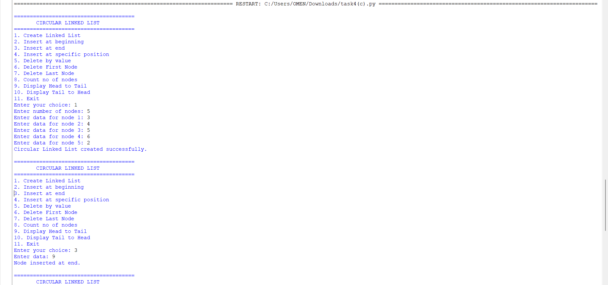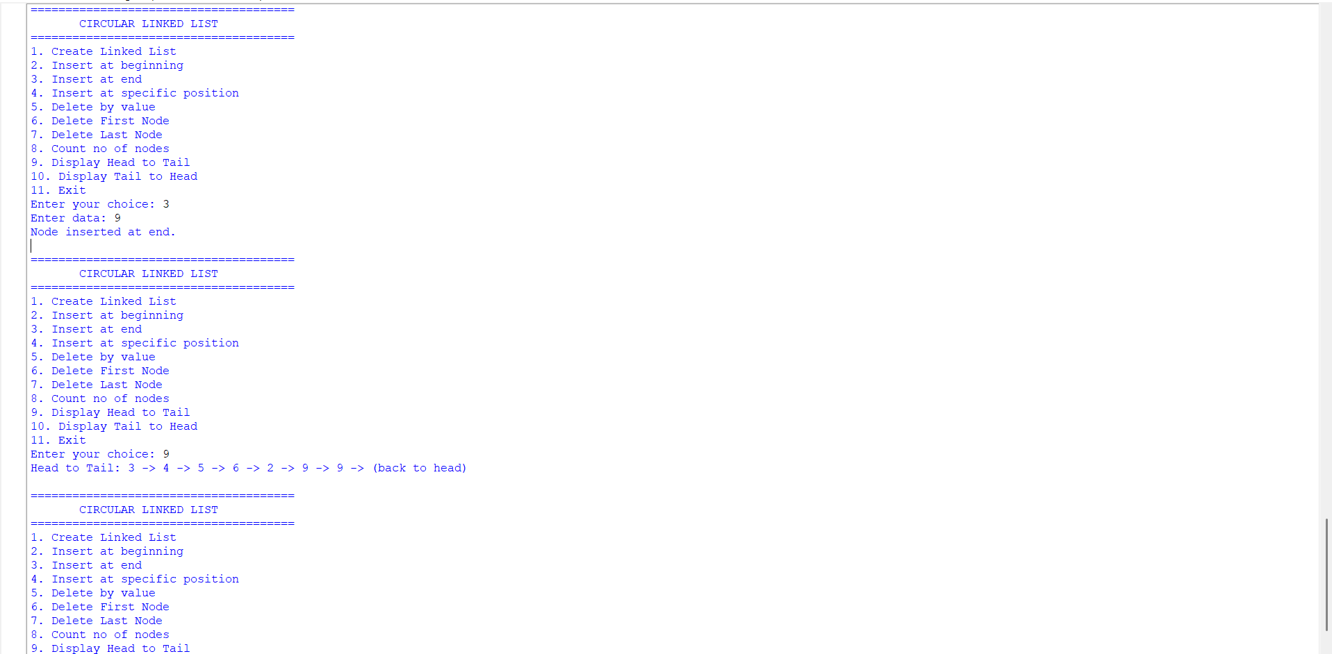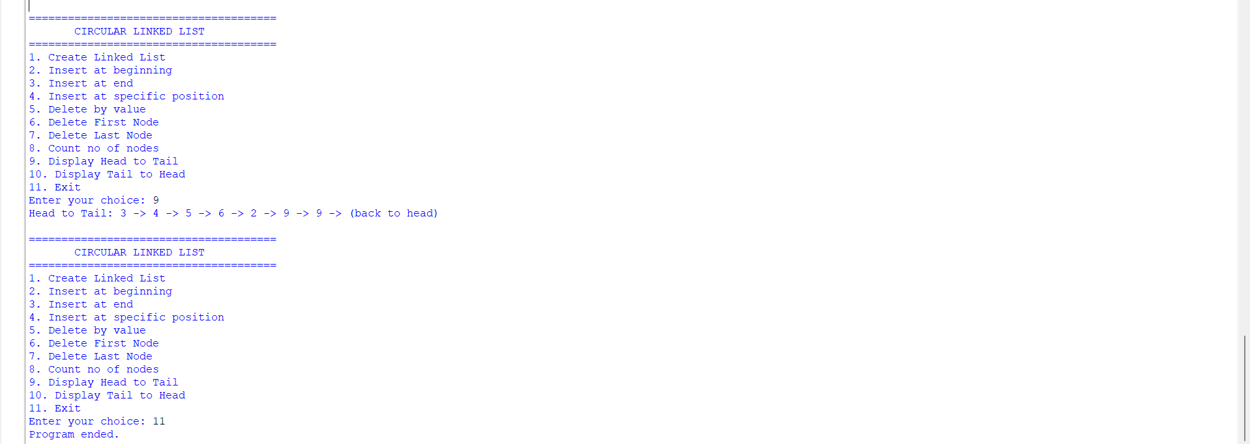

Explanation
- The program implements a Circular Linked List using a Node class.
- Each node contains data and a next reference.
- The last node points back to the head, forming a circular structure.
- Nodes can be inserted at the beginning, end, or a specific position.
- Nodes can be deleted by value, from the beginning, or from the end.
- The program counts the nodes and displays the list in head-to-tail and tail-to-head directions.
- A menu-driven approach is used to perform all the operations.

WEEK – 5

5)aim:-
write a python program to implement a stack using an array, linked list. Also
implement the stack operation such as push, pop, peep and also display the stack elements

Program:-
stack = []
while True:
print("1.Push")
print("2.Pop")
print("3.Peek")
print("4.Display")
print("5.Exit")

choice = int(input("Enter your choice : "))
if choice == 1:
x = int(input("Enter element to pop:"))
stack.append(x)
print("Pushed : ", x)

elif choice == 2:
if len(stack) == 0:
print("Stack underflow")
else:
print("Popped : ", stack.pop())

elif choice == 3:
if len(stack) == 0:
print("The stack is empty")
else:
print("Top : ", stack[-1])

elif choice == 4:
print("Stack : ", stack[::-1])

elif choice == 5:
break
else:
print("Invalid choice")

Output:
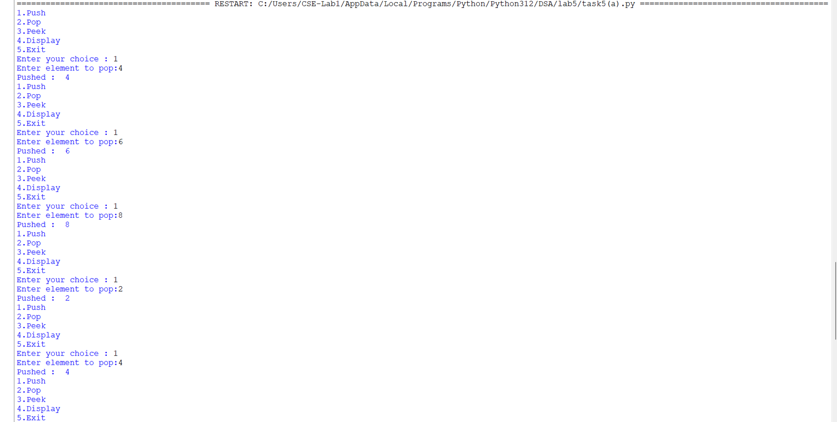
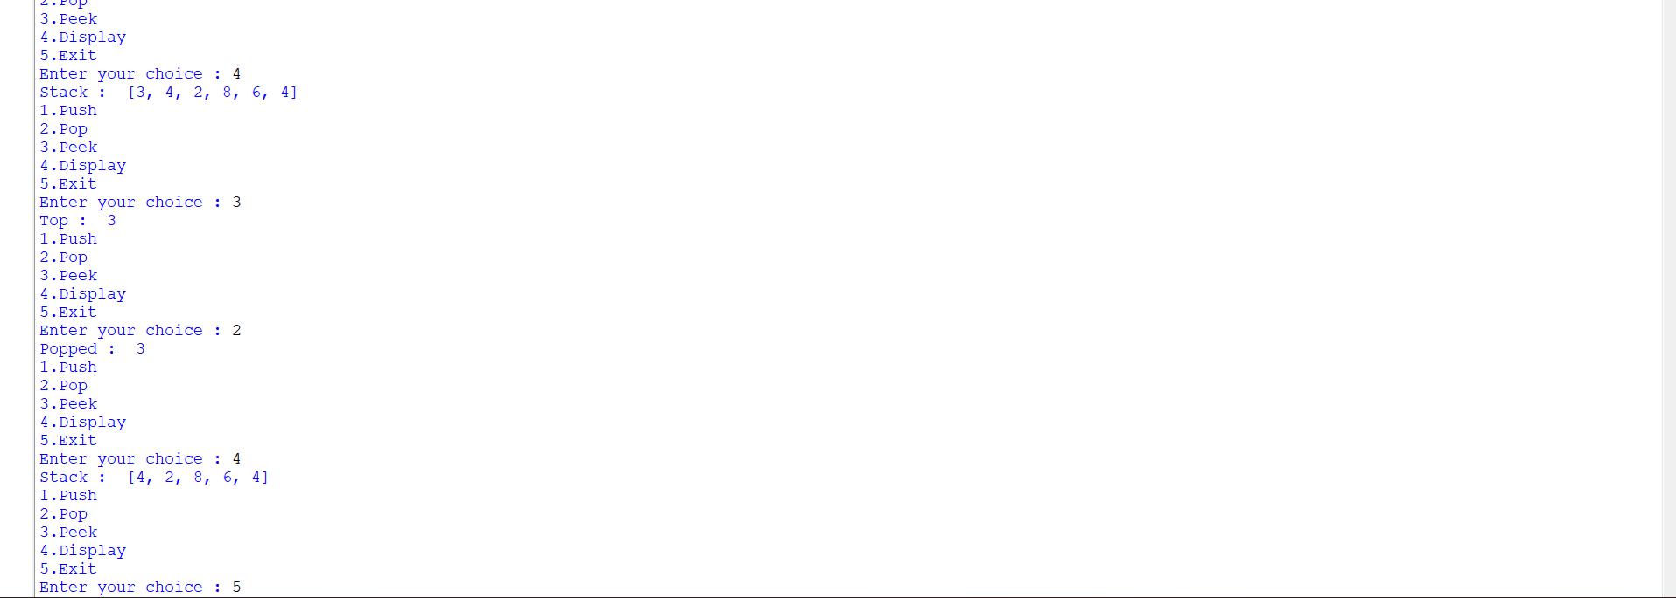
Explanation:-
This Python program implements a Stack using a list. A stack follows LIFO (Last In, First Out).
- stack = [] → Creates an empty stack.
- Push → stack.append(x) adds an element to the top.
- Pop → stack.pop() removes the top element.
- Peek → stack[-1] shows the top element without removing it.
- Display → stack[::-1] displays the stack from top to bottom.
- Exit → break stops the program.
- If you try to pop from an empty stack, it shows Stack underflow.
Note: There is a small typo in the Push section:

